**Issue Listing**

**Note: - Please check the Android screen and make the UI changes same in IOS.**

While sending this document to me with the status please make sure that on every point status should be mention as

1. WIP
2. DONE
3. **Login Screen:**
   1. User type dropdown not populated above the “Username” input filed.
   2. Space between userType and username is too much need to align all this spaces.
   3. On login page footer icon not disabled.
   4. On “Forgot Password” add underline to show as it’s and link.
   5. Change the button as circle layout with Icon.
   6. On login failed show the popup screen as shown below.

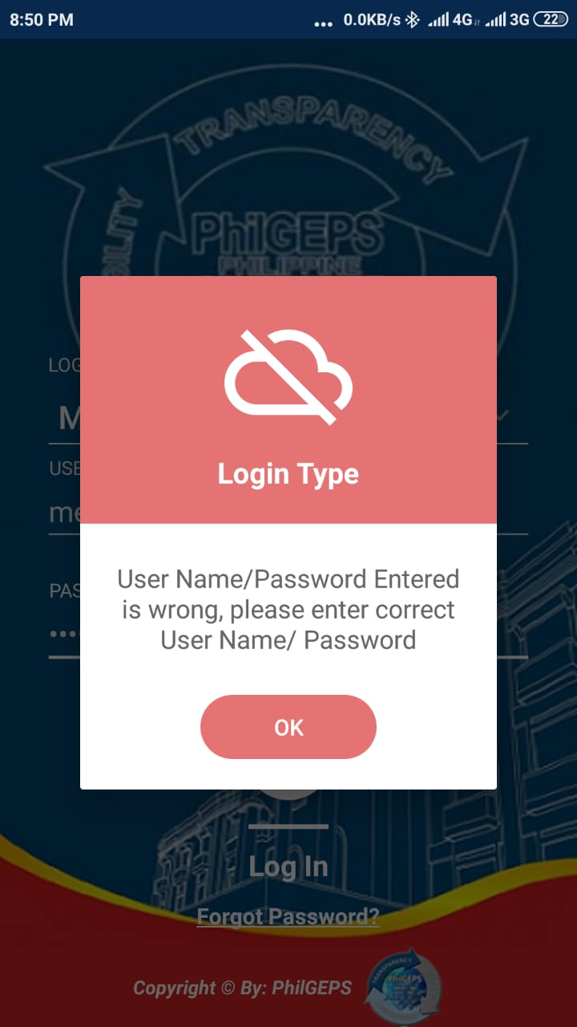

1. **Dashboard**
   1. Term and condition popup not showing if user login first time in the app. Check SRS document for more details
   2. Menu layout not align as per the Android APP may be padding or margin is missing.
   3. Header image showing background which not looks good.
   4. By default, 0 value is not showing for notification icon on top right corner of the main screen.
   5. On Menu click and back button press something happens in background and because of that UI shacking little bit.
2. **Sub Menu:**
   1. Menu layout is not aligned as per the Android App submenu.
   2. Selected menu name and icon not showing on submenu screen.

In below screen check that selected menu as “Bid Notice” is showing.

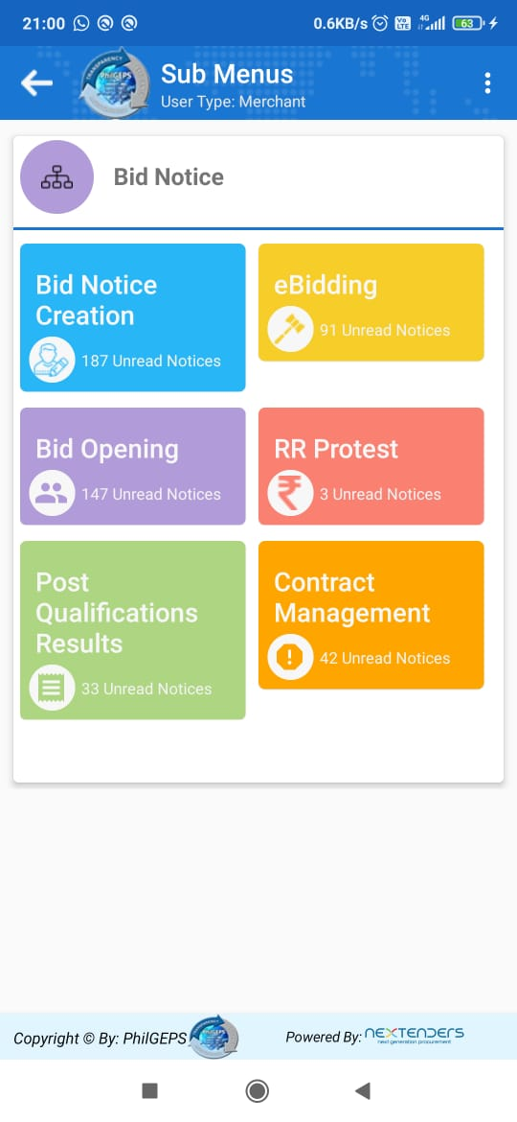

1. **Notice Listing**
   1. Menu title not showing in proper alignment check in Bid Notice >> Bid notice creation. Title should show in single line only.
   2. Proper bold format is not applied for list title.
   3. As icon used in Android use the same icon with color in this APP as well.
   4. Make the total row section non-transferable. So that data content will not be override to any other content. Also decrease the size of box.
   5. Check footer alignment it’s not attached to footer section of mobile.
   6. On Setting icon click empty menu shown below the settings menu.
2. **Detail Page:**
   1. On details page please refer the android app design.
   2. Check the header title it should not override the setting menu.